

CYMDEITHAS PENFRO YR YMDDIRIEDOLAETH GENEDLAETHOL

PEMBROKESHIRE NATIONAL TRUST ASSOCIATION
In support of the National Trust in Wales

NEWSLETTER No. 57

Spring 2025

FROM YOUR CHAIRMAN
JANE MASON

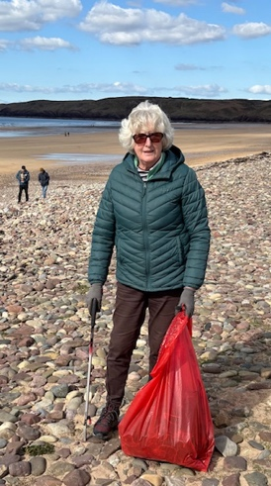

Taking part in the National Trust beach clean at Freshwater West

The problem is not large plastic things at the moment, but lots of plastic lids, short pieces of green and coloured string from tying off the fishing nets and other tiny bits of plastic.
Volunteers are always welcome.

Spring has sprung and your committee have been busy beavering away organising a varied programme of visits and walks for PNTA members this summer. We look forward to socialising with our members on these friendly events.
We are excited to announce the willow sculptures you supported are now proudly walking in the Stackpole gardens near the summer house, very close to the car park. If you visit, please take a photo of yourselves beside them and send to me.

The committee has now selected the 2024 Pembrokeshire National Trust projects that will receive financial support. A total of £3,000 is being allocated as follows:
£500 to the Tudor Merchants House for replacement hurdles in the Tudor Garden area
£1000 for Southwood seating along the footpath
£500 for Little Milford path improvements
£1000 for Southwood path improvement and a contribution to the cattle pen, used to round up the cattle to check their GPS collars on the farms practising regenerative farming.
Thanks once again, must go to Annie and Andrew Weaver for organising their ever-successful PNTA tours which helps to boost the funds raised.
Please don’t forget to ask me if you wish to put up a PNTA poster locally or some of our new Association publicity leaflets.

Thank you all for your continued support.
Jane Mason
jmason@fastmail.com
Chairman

Reports:
Habitat Restoration and Enhancement at Marloes Mere
Saturday 28th September

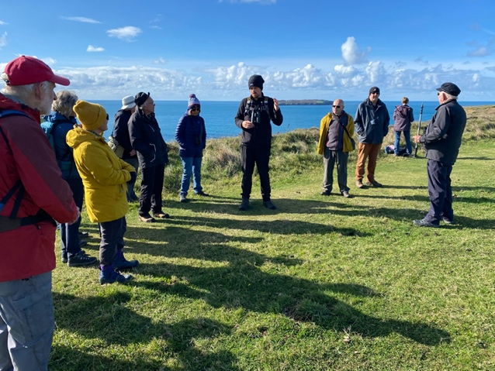
Ranger George Mee guides us on the coastal path.

NT Nature Recovery Ranger, George Mee, led this walk starting at the Marloes NT car park. George explained that the main purpose of the walk was to view the extensive works that NT have been doing recently at Marloes Mere, and then to walk through onto the coast path, hopefully to see seals and view the coastal scenery.
He outlined the main objectives of the habitat restoration scheme, namely, to restore about 1.5 hectares of wetland, by removing the banks or bunds from an existing irrigation pond (dug in the 1970s), thus reconnecting the deep-water reservoirs to the surrounding wetland habitats. This will gradually enable a variety of wetland habitats to re-establish, to include shallow water areas and marshy margins. The project has also improved the access path, by raising it up to provide better views of the Mere and the adjoining land. This will provide better access to the Britton bird hide and the Wales Coast Path. It is also much more accessible to less mobile visitors, such as those using all terrain scooters and wheelchairs.
We looked at the recent major enhancement works, opening up the views of the Mere, with talk of a new bird watching hide for the future – consultation with birdwatching groups is ongoing. George said that September and April are the best months for migrating birds and ones that overwinter such as wigeon. Donations towards the major landscaping works had come from the Waterloo Foundation, Natural Resources Wales, the Langdale Trust and from private donors.
Having admired the much-improved views of the Mere and wetlands, we walked on through the hay meadow which had been recently cut, with bales of hay resting all over the field.
Leaving the hayfield, we headed towards the coast path and entered an area of heathland. George explained that, in order to restore the heathland habitat (from previously farmed land), NT had needed to reduce the fertility, so they had scraped off the topsoil and applied an acid substance. To buy in a commercially available sulphur-based product would have been too expensive, but luckily the Valero refinery had a by-product which was surplus to their requirements, so this was delivered and spread across the area, to expedite the return of the heathland flora.
Strolling across the heathland and onto the coast path, we saw chough and several reptiles – George is an expert on these.

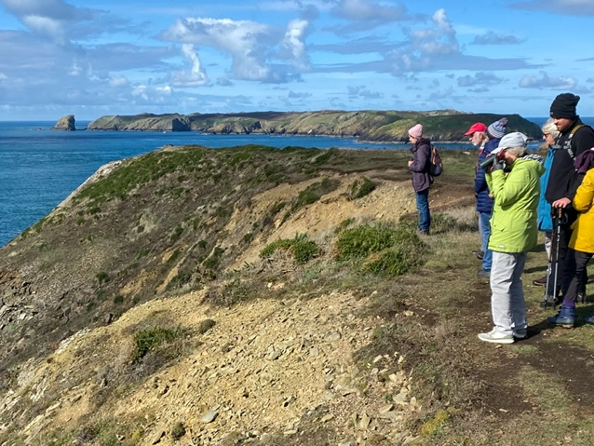
Seal watching near Marloes

Plenty of seal pups were visible in the bays below the path, which we could observe without causing any disturbance. George said that one could expect to see snow buntings in this location in winter. Sheep are brought in to graze the heathland in the winter months.
After admiring the superb views towards Skokholm and the Deer Park we turned back and returned via the coast path above Marloes Sands – truly a lovely vista! Many of the party enjoyed refreshments at Runwayskiln, after the stroll.

Report by Steve Drinkwater

Reports on Autumn/Winter talks 2024/25

October 3rd 2024
Katie Barrett. The Unusual Life of Cesar Picton.



Katie is Heritage and Education officer at Picton Castle Gardens. Her role is varied and includes creating educational tours, workshops, and writing resources on aspects of Picton Castle’s fascinating history.
Picton Castle was built in 1280. From 1491 until 1997 it was the home of the Philipps family. The Philipps family comprised Sir John Philipps, Lady Elisabeth and four children; Richard, Katherine, Joyce and Mary. Sir John was well renowned for looking after his staff. He was a social and religious reformer who supported education for working people. He supported Charity schools and sponsored two editions of the Welsh bible. He also, funded scholarships at Oxford for students born in Pembrokeshire.
During this period, it was unusual for persons of black African origin to gain prominence in society. Cesar Picton was an exception. As another example a picture of Queen Charlotte (wife of George III) was displayed. Reference was made to the fact she may have African descent.
Cesar was born in Senegal and bought to Britain in 1761 (aged about six) by Captain John Parr. Parr was a British army officer who had been serving in West Africa. The earliest reference to Cesar was in the journal of Sir John Philipps. Sir John was MP for Pembrokeshire and resided at Norbiton Place, Kingston upon Thames. Cesar, along with a parakeet and foreign ducks were gifts from Captain Parr to Sir John.
Sir John had Cesar baptised and three upper servants from the household were his godparents. It was common for blackboys to train as servants and be dressed in exotic attire. Sir John bought a turban for Cesar to wear.
In June 1762, Cesar and the entire Philipps family travelled to Picton Castle. It was here that Cesar had education and training in household duties. Cesar was never a servant. He was well treated, respected by the family and accepted as one of their own. On the death of Sir John, Cesar was not named in the will. However, on the death of Lady Philipps (1788) the generous sum of £100 was bequeathed. She expressed hope that her daughters would give some care to Cesar and not allow him to want. Her wish was fulfilled. The politician Horace Walpole mentioned Cesar in a letter and described him as being “remarkably sensible”.
Lord Milford (Richard Philipps) sold Norbiton Place where Cesar and the Philipps ladies often stayed and began a renovation at Picton Castle. The Philipps daughters moved to Hampton Court and since they were unmarried it was not proper for Cesar to go with them. Cesar moved and rented a fine house in Kingston. The house had a wharf and was ideal for a business. The business chosen by Cesar was that of a coal merchant. This was an ideal and necessary business during the Industrial revolution (1760 to 1840). The rental agreement shows his name as Cesar Pickton and may be attributed to his regard of Picton Castle.
On the death of Sir John’s daughters Cesar received legacies from each. This enabled him to buy and rent properties allowing his prosperity to grow. Cesar had become accepted as a gentleman. He appeared before probate officials and acted as a witness for Lord Milford’s will. When accused of poaching Cesar was fined a relatively modest amount of £5. A less privileged person would have received a much harsher sentence.
Cesar had become a wealthy and respected man. He died in 1836 aged 81 having enjoyed good health. He had never married, had no heirs and left his wealth to his god daughter. A portrait painting of Cesar was left to his friend (Thomas Bushell). Unfortunately, it is not known what became of the painting.
From a humble beginning, Cesar is often referred to as a 'gentleman'. He was clearly an intelligent businessman and accumulated substantial wealth throughout his career.
Katie has written a piece on Cesar Picton for the Dictionary of Welsh Biography, which can be found at https://biography.wales/article/s15-PICT-CES-1755

Report by Graham Wright

November 7th 2024
Glyn Harries Historical Figures of Tenby
Glyn Harries is the Outreach and Education Officer for Tenby Museum and Art Gallery-

Glyn’s talk was an interesting one to guess who would be profiled and there were certainly some surprises.
Thomas White and Henry Tudor. Thomas was Mayor of Tenby 5 times in the 1400s. He helped Henry Tudor escape to France, allegedly in a tunnel that may be under Boots the Chemist and Tenby was subsequently awarded the Royal Charter and lands for his aid.
Robert Recorde -born in Tenby in 1512 was a mathematician and while translating algebra into the English Language invented the = sign. He also invented different weights which led to clearer amounts for tax purposes.
Sir William Paxton 1744, born to a merchant midshipman, Sir William became a very wealthy merchant in his own right. He bought a lot of land in Tenby and started the development of Tenby as a seaside resort, building the bathing house near the harbour.
Peggy Davies 1727-1809. Peggy operated the South Beach bathing machines becoming an assistant helping people into the water, becoming renowned for her gentle and caring manner.
Margaret Jenkins 1928 the 526th Mayor of Tenby. Involved with the Red Cross in the Second World War she sat on the Council for 25 years. Her daughter became the first woman member of Pembrokeshire County Council.
Nina Catherine Stokes 1873-1963. Nina taught and nursed on the front line in the First World War with the British expeditionary force.
Frank Britain Mason 1856. The Mason family were journalists and Frank was often controversial leading him to be barred from Council meetings, but he went anyway. Eventually the Press bill said journalists had to be admitted, which was of local and national importance.
Gwen and Augustus John, both famous artists. Gwen was born in 1876 to a family of solicitors in Haverfordwest, the family relocating to Tenby to avoid an outbreak of scarlet fever. Augustus was born in Tenby in 1878. Gwen went to the Royal Academy and lived in France and was a reclusive child with obsessive attention to detail. She died in 1939 collapsing in a street in Dieppe. Opposite to Gwen, Augustus was an extrovert and while swimming at Giltar Point he fell and hit his head, which is believed led to him changing character and leading a very Bohemian life.
Report by Jane Mason

December 5th 2024
Gareth Mills. History of the Stackpole Estate

The talk began with our Chairman, Jane Mason, showing a selection of photos and postcards, permission of The National Trust, WE Morgan Collection. These were unique due their age and gave an insight to early 20th century life on Stackpole Estate.
Our speaker Gareth Mills gave an interesting and extremely detailed talk about the History of the Stackpole Estate.
Stackpole forms a natural inlet from the sea and the name is of Viking origin. Human activity may be traced from the Bronze Age, evidenced by a standing stone “The Devils Quoit” and a burial chamber.
The history of Stackpole goes back to the 12th Century when the Normans invaded South Wales. First known owners of the estate were the de Stackpole family followed by the Stanleys. The Stanleys hired the Lort family to administer the estate who in turn purchased it. Elizabeth Lort heiress to the estate married Alexander Campbell Thane of Cawdor (1689). The Campbells being of Scottish royal heritage, meant the Stackpole estate owners were politically and economically powerful. Notable historical visitors to Stackpole included Nelson, George IV, Edward VII and Duke of Gloucester.
The original house at Stackpole Court was built on the foundations of an old, fortified manor house. Successively the Campbells completely transformed the house, gardens and estate. The original site of Stackpole village was moved for a new deer park. The valleys below the house were dammed and lakes were formed. A walled garden was created with heated sunken beds allowing exotic fruits to be grown. A pineapple grown here graced the kings table (1821).
By a succession of John Campbells and their achievements, Stackpole became renowned. Several became politicians or held esteemed military posts. The defeat of French forces at Fishguard was led by Lord Cawdor. Using new agricultural methods along with breeding of cattle, sheep and growing root crops the estate became extremely productive. The Suffolk punch workhorse was introduced on the estate.
The old house was eventually replaced by a large Georgian Palladian mansion that had 150 rooms. Stackpole became one of the great estates of South Wales. Being under constant renovation and upgrade the house became a struggle to maintain and upkeep.
During the war the decline and ruin continued. Soldiers billeted there removed lead from the roof. In 1963 owner Hugh John Vaughan Campbell
(1932-93) applied for planning permission to refashion the house to a more manageable size. Planning refusal led to demolition of the property.
Recommended reading: Liza Campbell (daughter of Hugh Campbell) tells the story of her childhood in Wales and move to the Highlands when Hugh inherited Cawdor.
- Title Deeds 9780552772983
- Charmed Life 9780312374778 (ISBN10: 0312374771)
Please note the different titles are for same book.

Report by Graham Wright

January 9th 2025
Alex Shilling - Active management of National Trust Woodlands (focussing on South Pembrokeshire).

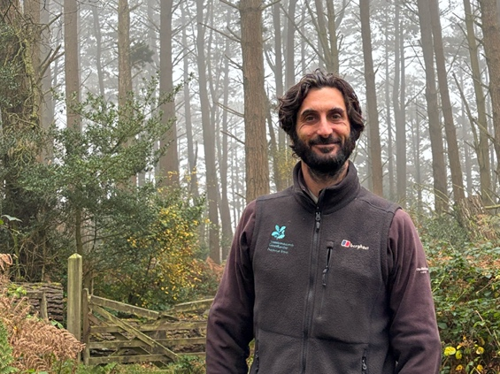

During his 12 years in Pembrokeshire, Alex specialised in woodlands, establishing coppice rotations, ride management and restoration of the ‘informal arboretum’ in Stackpole; managing the clearance of over 1000 windblown trees in 2014 and subsequent replanting of over 12000 broadleaf trees; most recently he has been Project Manager for the Stackpole TWIG project and part of the team to successfully apply for TWIG funding for Colby, for which he is now Project Manager.
Alex gave an informative talk about management of woodlands across Pembrokeshire with the challenges and benefits that this management brings.
There are 4000 hectares of land, owned by the National Trust, across Pembrokeshire. This includes walled gardens, lakes and ponds. Site locations such as Colby, West Williamson, Little Milford and Stackpole contain Sites of Special Scientific Interest (SSSI), National Nature Reserves (NNR) and Special Protection Areas (SPAs).
In woodlands there is often a lack of structural diversity. This refers to the variation in different size trees both vertically and spatially. Controlling the height and spread affects the amount of light on the forest floor and ultimately the flora and fauna.
Water is often a problem. Where possible natural flood interaction methods are used to slow the flow of water across land.
Woodlands contribute to tackling climate change and net-zero. Reforestation and rewilding help in reducing carbon emissions. The National Trust has a ten-year program which aims to have planted and established 20 million trees by 2030.
Protecting and enhancing cultural heritage is important. This includes banks, hedges, and reminders of our industrial heritage.
Tree management in woodlands is important in protecting the health and safety of visitors and staff. It contributes to the local economy allowing development of allied businesses with resultant staff hiring and subcontractors.
Stackpole typically highlights the challenges for woodland management and is home for a large colony of greater horseshoe bats. Trees and shrubs from around the world were planted at Stackpole originally for ornamental viewing. However, through self-propagation these became Invasive Non-Native species (INNS), (e.g., laurel, himalayan honeysuckle and holm oak), making it difficult for native plants to compete. Funded by the Woodland Investment Grant (TWIG) and working in partnership with other specialists improvements have been made including removal of INNS also, the clearing and widening of some pathways.
A single species of tree gives a fragile woodland, ideally, we should look to four or five varieties. Bird nesting season, early spring to late summer, means management work is often carried out when ground conditions are not favourable. At Colby, a natural deciduous woodland is being developed, conifers are being removed and replaced with oak and sycamore, amongst others. Lawrenny Wood (NT) is a site of Special Scientific Interest (SSSI) and considered a hidden gem with horseshoe bats and lichen.
Long term planning for woodlands is essential and should look 10 years or even to 50 years in the future. Work should be prioritised by need.

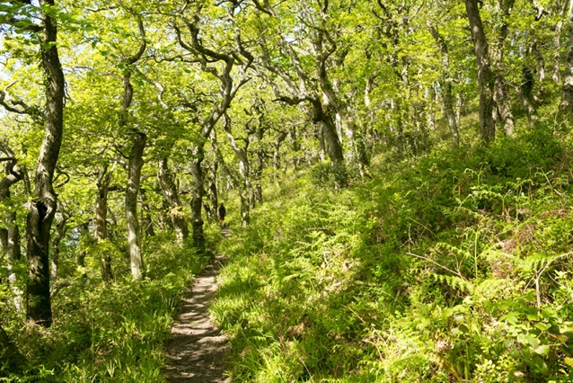
Public footpath through Lawrenny Woods

Report by Graham Wright

February 6th 2025
Dr Julian Whitewright - Maritime Archaeology in Wales: The work of the RCAHMW

Dr Julian Whitewright is a maritime archaeologist and Senior Investigator (maritime) for The Royal Commission on the Ancient and Historical Monuments of Wales (RCAHMW).
Julian grew up in Pembrokeshire. He left to go to university and study archaeology at the University of Southampton. One of Southampton’s great strengths is maritime archaeology, a subject which increasingly fascinated him during his BA … which became an MA in maritime archaeology … which (eventually) turned into a PhD.
Julian’s talk showcased the maritime archaeological work undertaken by the RCAHMW to curate and update the maritime element of the National Monuments Record, and described work done to record archaeological remains in the intertidal and coastal areas of Wales. Much of this work takes place in areas owned by the National Trust, including several within Pembrokeshire, used as examples within the talk.
RCAHMW was established in 1908 by Royal Warrant and its work is to maintain records about the archaeological, architectural and historical heritage of Wales. The term ‘natural monuments’ is very diverse and includes harbours, hill forts, wrecks and schools.
The National Monuments Record of Wales (NMRW) has over 8,000 maritime records with reference to shipwrecks, crashed aircraft, submerged forests, harbours and fish traps. Examples given: A second world war crashed aircraft (type P-38 Lightning) that crashed off the north Wales coast. The wreckage is not always visible however, it remains well preserved. A medieval fish trap just off Poppit Sands https://coflein.gov.uk/en/site/24568 . The remains of a submerged forest at Newgale Beach https://coflein.gov.uk/en/site/524759. The remains of two ships can be seen at Gellyswick Bay https://coflein.gov.uk/en/site/406638/.
Julian stressed the challenge to manage and conserve each site. Each holds unique information about people from the past and once lost, it is gone forever. Maritime archaeological sites are continually threatened by climate change or natural processes. Severe weather events, coastal erosion and changing sediment patterns play a detrimental part in causing burial or damage to a site. There are many techniques and methods used in the field of Maritime archaeology i.e., surveying, documenting, aerial Lidar, UAV photogrammetry, rope survey, GPS, laser scanning by drone and using divers. Advances in technology now allow sites to be documented by a small team in a short space of time. The wreck of the steamship ‘Henry Bell’ and the cast iron ‘lighthouse’ at Whiteford Point were shown as examples where digital processes have been used to preserve a site. The following links are provided for you to explore the 3D models. shipwreck-henry-bell lighthouse-whitford-point.
In photogrammetry a ‘point cloud’ is created. It is a 3D digital representation of the survey site and consists of millions of individual points. The points are then overlayed with overlapping photographs and distortion removed. This composite image may be compared to imaging from a later date to ascertain if there has been degradation or changes at the site. Further processing may produce a coloured contour map of the site. Finally, the point cloud could be used to generate a mesh of triangles. Each triangle could then be textured to create a 3D model of the site.
Repeat scans are conducted at intervals to determine changes and actions to preserve the site. The village of Abereiddi was shown as an example of coastal erosion after a storm. Abereiddi errosion
The threats to marine archaeology sites are continuous. The recent storm ‘Darragh’, coastal defence schemes and offshore renewable energy projects pose challenges to manage, preserve and protect our cultural heritage for current and future generations.
The talk included many pictorial examples, and it is recommended that you visit the links to see and understand the splendid work done by RACHMW.

Report by Graham Wright

March 6th 2025
Loveston Colliery Disaster
David Llewellyn Tenby Museum and Art Gallery Curator,



Originally from Tenby, David has had a lifelong love of both history and the town itself. He studied history with the University of Wales before going on to become a professional archivist.

David provided an overview of the history and geography of the Pembrokeshire coal field from its earliest days until final closure. He explained about the challenges and dangers involved in the local coal industry before moving on to the main subject, the Loveston Colliery disaster of 26 May 1936. The flooding of the mine resulted in the loss of 7 men and caused an immense shock to the local community.

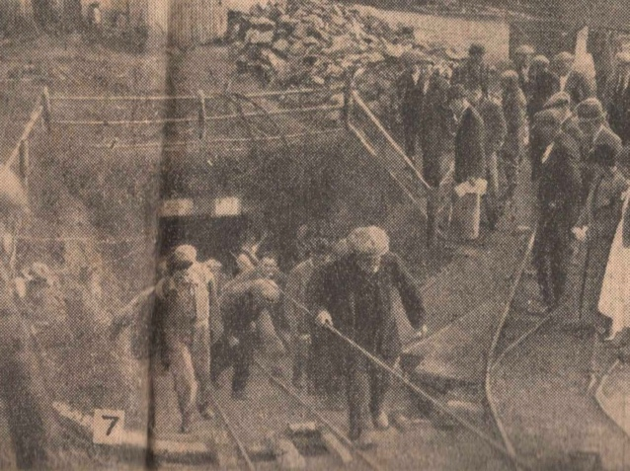
Western Mail photograph, miners returning from the rescue operation.

Through the words of the miners themselves David built a picture of the day itself and how the dramatic events unfolded underground. He also told the story of the impact on the community in the aftermath and examined the official responses to the event. An active Q&A followed and David was pleased to engage with many members of the group after the talk.

Report by David Llewllyn

SUMMER WALKS & DAY TRIPS 2025
Walks for Summer – Steve Drinkwater

Following the same pattern as in 2024, I have organised three walks for this summer. Each is relatively short, with an emphasis on interpretation of the location and topic. Numbers on each walk will be limited to 20. I will take bookings, preferably by email or text, commencing one week before the event in each case. More details will be given in Mailchimp in advance of each walk.

Please note that for insurance purposes if you wish to go on any trips or walks you will need to be a paid up member of the PNTA.

Wednesday May 14th 2pm – 4pm Exploring the Old Port of Haverfordwest - with Dr Simon Hancock.
This walk will be similar to the one that Simon led last year for the Friends of the Pembrokeshire Coast, which was very interesting and kept us enthralled for the duration.
It will explore and explain the fundamental importance of the river in the history of Haverfordwest from medieval times right up to the 1930s. The terrain will be on hard surfaces and the pace, slow. Simon is well known as an eminent local historian who is also the custodian of Haverfordwest Museum. There may be an opportunity to meet up beforehand for lunch, details will be given in the relevant Mailchimp.

Thursday July 24th 11am – 12.30pm Exploring a recently acquired NT property - Cilau Ganol near Goodwick - James Roden, NT Lead Ranger
This walk will explore the locality of Cilau Ganol, a small farm which NT purchased to link up two existing NT landholdings. It is situated on the hill behind Fishguard Harbour and hopefully there will be excellent views if the weather is kind! James will explain why the property was bought and the proposals for future land management at the site, with an emphasis on promoting biodiversity across the three properties. The walk is fairly short, mostly easy going on farm tracks and grassy fields, but there is a short section on the Coast Path which consists of large boulders through a boggy section. Boots will be necessary and walking poles strongly recommended for this part.

Monday September 22nd 1.30 – 3.00pm Interpretive Walk at NT Colby Woodland Garden - Steve Whitehead, Head Gardener
Steve has a massive fund of knowledge about the site, having worked there for many years. He led a walk there for PNTA some years ago which was popular. This walk will cover the history of the garden, including the planting strategy over many years, recent storm damage and the wildlife to be found there. He will also describe the earlier history of settlement in the valley, including Colby Lodge itself, notable people who lived there and the background to coal mining in the locality which was so important in the past. The terrain is on gravel paths, with the possibility of some moderate gradients. Members may wish to have lunch, and/or tea at the Bothy Tearoom.

The booking contact for the walks is Steve Drinkwater. Email: steve.drinkwater68@gmail.com
Phone: 07761231325.

Hilton Court Wednesday 30th April
Arrive between 10.30am -11am. Coffee is available to purchase in the cafe.
Time for a leisurely walk through the woods and gardens and hopefully a peaceful sit by the water.
Entrance to the garden is £5 each.
Lunch -sandwich with crisps, hot drink and homemade cake £10.
Choice of sandwiches, ham and tomato, cheese and pickle, egg and cress and chicken and bacon.
As there is now only limited admission to Hilton Court, we will have the cafe and gardens to ourselves.
To register for the visit and give sandwich orders please contact Lyn Humphries on
01646 621159 or e mail lynb.humphries@gmail.com before the 23rd April 2025

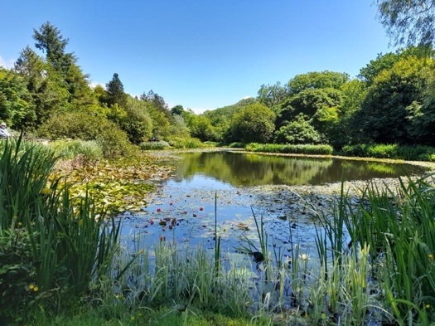
Lily pond photograph Lyn Humphries
PNTA SUMMER DAY TRIPS 2025

Thursday 12th June
A TRIP ON THE GWILI RAILWAY

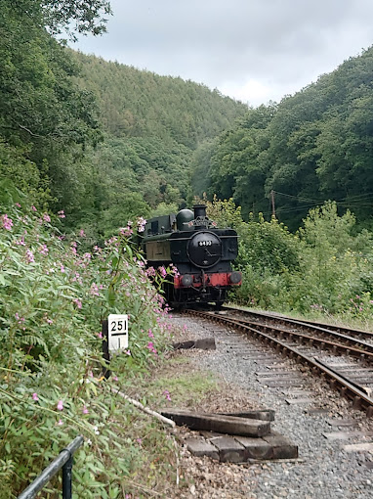

A morning train ride with refreshments en route (Welsh Elevenses) through the lovely Carmarthenshire countryside lasting one hour thirty minutes. The train departs Abergwili Station at 10.45am and returns at 12.15pm. The cost is £24.99 per person to be paid at the station. Alternatively, should you wish to forgo the refreshments the basic train ride is £17.00 per person. There may be a small discount for an organised group. We will meet at Abergwili Station carpark at 10.15am at the latest. If you would like to go on this trip, please let me know (with your train ride option) by 16th May latest.
Afterwards, to extend the day, members might like to visit CARMARTHEN MUSEUM & BISHOP’S PARK (situated nearby at the next roundabout on the A40) where lunch can be bought if desired in Y Caffi onsite. Or you may decide to bring a picnic lunch. Members will have an opportunity to visit the Museum which offers a comprehensive history of the county of Carmarthenshire and its people through the ages. In addition, you can explore The Bishop’s Park, a lovely extensive park with walled garden, wildlife-rich woodland and meadows and an ox-bow lake. Entry is free but they recommend a donation of £5.00pp to help maintain the museum. It closes at 5pm.
Transport by own cars (sharing advised).

Thursday 10th July
THE DOLAUCOTHI GOLD MINES & DOLAUCOTHI ESTATE
A visit to the only Roman Gold Mines in Britain where you can take an underground tour or browse around the Mine Yard and its many attractions. You can even try panning for gold! If you are feeling energetic you can take to the footpaths and explore the woodland, farms and parkland around this beautiful 2500-acre estate. This is a National Trust property and therefore entry is free to Trust members. There are three different underground tours at various times throughout the day to choose from. Go to…
https://www.nationaltrust.org.uk/visit/wales/dolaucothi/booking-your-visit-to-dolaucothi for more information and to book your own tour in advance. It appears that The Roman Tour at 11.30am and 2.00pm is the most popular with a maximum capacity of 15 people.
There are no café facilities onsite and so it is suggested that members bring a packed lunch that we can enjoy together at a pre-arranged time and place.
This is also a self-drive visit and car-sharing is recommended.
It would be useful to know in advance how many members intend going on this visit. I would be grateful if you could please let me know.

Thursday 14th August
A VISIT TO LLANELLY HOUSE

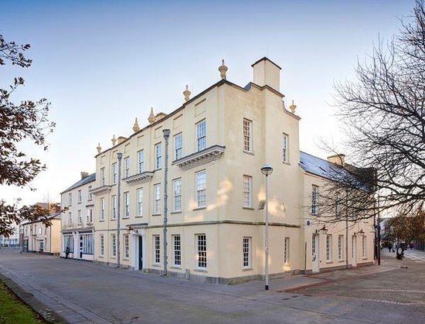

Llanelly House is one of Wales’ finest surviving Georgian townhouses, steeped in rich history and architectural grandeur. Built in 1714, the House has witnessed the transformation of Llanelli from a small market town into an industrial powerhouse. Following an extensive restoration, it now stands as a testament to the town’s heritage, offering visitors a glimpse into the past.
A guided tour will be provided for our group starting at 11.00am and lasting one hour and thirty minutes at a cost of £8.50pp. Afterwards lunch can be bought in the on-site Bistro.
On the return journey we will visit…

KIDWELLY CASTLE where we can explore this fine Norman edifice, cared for by CADW, and visit the ‘Time Travelling Medicine Man’ exhibition. This describes the history of medicine, surgery and dentistry through the ages.
Admission: £7.00 (Over 65’s) and free for CADW members.
There are toilet facilities there but no tea room. However, it is hoped that we can arrange for tea and other refreshments to be laid on at a nearby establishment.
Travel will be by coach leaving Haverfordwest Rugby Club at 8.30am.
The charge for the coach will be £25.00 per person
The total cost of this excursion (excluding lunch and refreshments) will be between £33.50pp and £40.50pp depending on CADW membership.
A booking form will be included in a future Mailchimp or bookings can be made directly with Graham. Contact details below.
Firm bookings will be required by 25th July at the latest.
For further information about any of the above trips or expressions of interest in going please contact Graham Brace at grahambrace@btinternet.com
Mobile:07398532174
Landline: 01437 891580

NATIONAL TRUST NEWS


Rhian Sula General Manager for Pembrokeshire.

Dear All,
Spring has certainly started with buzz and the team are feeling very enthused and excited to start the season. These past few weeks of sunshine and dry weather have made a very positive impact not only to the number of visitors, but our places are starting to pop with colour and the dawn chorus is such a welcome sound. It’s my favourite time of year as I get my bike out of hibernation and it’s light enough to go running in the morning, and I’ve even had a few chilly sea dips.

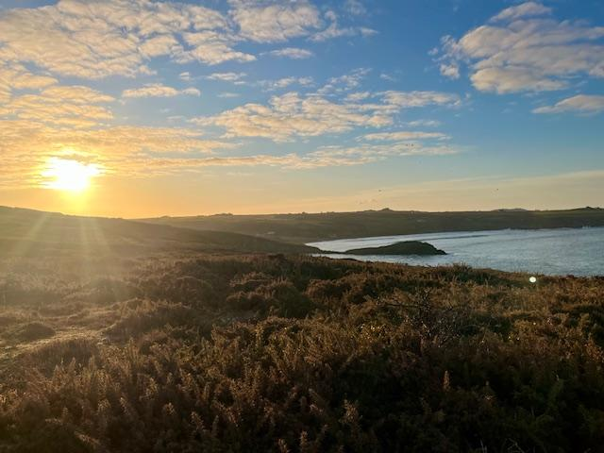
Sunset at Freshwater West
Photograph Rhian Sula

In January we celebrated the National Trusts 130th birthday by unveiling hugely ambitious plans for the next decade and beyond, as we launched our new 10-year strategy ‘People and Nature Thriving’. People and Nature Thriving follows the largest public consultation ever carried out by the Trust, with more than 70,000 people – including members, volunteers and industry partners – sharing their views on the Trust’s work and direction. This consultation has provided the building blocks for the strategy, which will guide our work over the next ten years and beyond.
At its core are three ambitious 2050 goals: to restore nature, to end unequal access to nature, beauty and history, and to inspire millions more people to care and take action. We will be finding out more over the next month what this looks like for us in Pembrokeshire, but we are all excited for this next chapter and know this will be very positive for our portfolio.
Our big projects (Stackpole Lakes, Southwood Estate, Newgale coastal adaptation scheme and Freshwater West) has taken our attention over the winter and it is looking likely that we will be focussing on the Newgale Coastal Adaptation Scheme, as it goes to Pre-App this month.
Some other exciting news is that we are in the process of renovating two of our empty cottages into holiday cottages. Cawdor Cottage in the heart of the Stackpole Estate and right next to the lakes, will be ready by July and Wood farm above Newgale will be our first 5-Acorn (5*) holiday cottage and will be ready by the autumn. I can’t tell you how excited and pleased I am to inject some love and life into these beautiful buildings, in the most incredible locations.
The start of the year has seen some staff changes, but I am so pleased that Emma Palmer has taken over the role as Business Services Lead for Pembrokeshire, Rebecca Evans has started as our Community and Participation Project Officer, and Mark Underhill will be leading on some of our major projects, which gives James Roden the opportunity to act up as Countryside Manager for Pembrokeshire.
Not only are we preparing for a busy Easter, but we have some exciting work happening across the portfolio including internally decorating Tudor Merchants House, the Colby Gazebo will take a much-needed focus this spring, we will be completing some backlog repairs at Southwood and we are looking forward to our cows giving birth soon.
And finally, I cannot tell you how pleased I am that the willow sculptors are finally coming this month, and we will be able to see them by Easter. Thank you for your very generous donation and thank you so much for your patience, it’s been a long time coming but we are nearly there.
Please do get in contact if you ever have any questions and here’s to a wonderful Easter filled with sunshine.

Marloes Mere
Report from George Mee Nature Recovery Ranger.
A full year has passed since we undertook work to enhance both habitats and access at Marloes Mere. The work focussed on removing artificial bunds, returning approximately 1.5 hectares to wetland habitats. The footpath was relocated to higher ground, creating a less muddy, more accessible route.

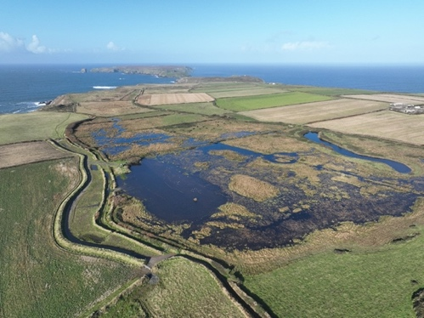
View across Marloes Mere

We’re happy to say that the work has been a great success. Initially the area appeared desolate but has quickly ‘greened up’ with lots of regenerating vegetation. Responses from visitors and locals alike have been positive. Avian visitors have been suitably impressed too, the highlight being a rare Spotted Sandpiper, who made the crossing from north America in late August.
The next phase of work will focus on upgrading the Britton hide, replacing the current, degraded structure. Having consulted with birders, visitors and members of the local community, we’re currently working on a design. The new viewing facility will be bespoke, seating about ten people, and with easy access for wheelchair users and those with mobility issues, offering a place to appreciate the specular scenery and wildlife.
.
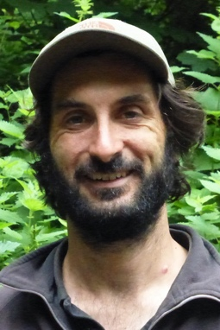
Report from Alex Shilling Lead Ranger
South Pembrokeshire
As another Winter draws to a close the South Pembrokeshire Ranger team reflect on a busy season delivering conservation and safety work across the region. While our planned woodland management work has been hampered by essential clearance and safety work in the wake of increasingly intense and frequent storms, restoration of the historic Lodge Park Wood at Stackpole resumed in the early part of 2025. By clearing some of the trees here, we have made space for the remnants of the historical planting, as well as creating opportunities to plant the next generation.
Across both Stackpole and Colby estates, important conservation and access work continues to be delivered through the Welsh Government and National Lottery Heritage Fund TWIG Woodland Improvement Grants. With the Stackpole Project having ended this January, we have celebrated some of its successes, including Natural Flood Management work in Caroline Grove, renovation and installation of interpretation at the Castle Dock wood hut and eradication of invasive plant species across the estate woodlands. Meanwhile, Colby TWIG is now 6 months in, with work also underway tackling invasive species throughout the woodlands, fencing erected for a new wood pasture block and woodland restructuring work carried out. We have also worked with the Friends of the National Park volunteer group to plant 1000 new trees to supplement those already planted at the Mount and Barn woodland creation.
Looking forward, we have a range of estate maintenance tasks planned in across all our sites to prepare for the new season ahead, improving car parking areas and access routes. We are also developing volunteering opportunities and wildlife monitoring priorities across our sites as well as planning our nature conservation priorities and operations for the coming years.

TUDOR MERCHANT’S HOUSE
Report from Melanie Knapp Senior House & Collections Officer

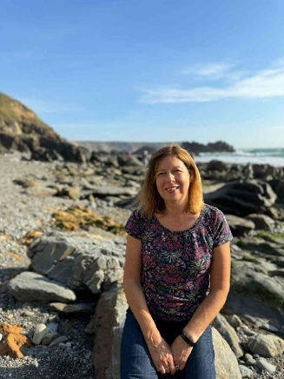

We have enjoyed another busy season welcoming again over 14,000 visitors to TMH. We have exceeded our expectations both in numbers and visitor feedback. It is very pleasing that our visitor numbers have remained consistent which has not been the same for all pay for entry properties.

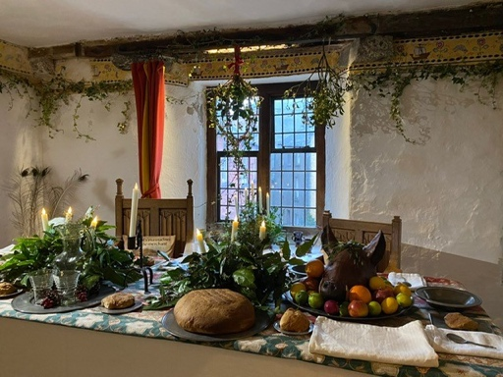
Christmas kitchen with wood and greenery collected from Colby
We had another successful Christmas Event despite losing the second Saturday to Storm Darragh with 315 visitors over 5 days, which included two schools for Tenby which was a real bonus.

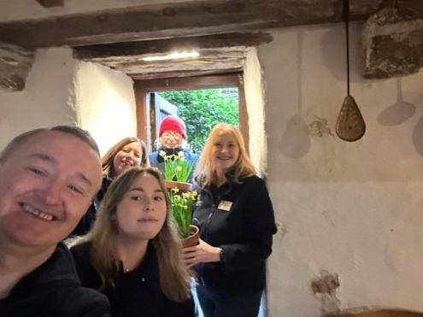
First day staff and volunteers

We have had our Start of Season Meeting and re -opened for the new Season on Thursday 20th February to coincide with the English Half Term. Our opening times will be the same as last year, three day opening on Tuesday, Thursday and Saturday until the end of September, two days in October and three Fridays and Saturdays end of November/early December for Christmas. Our pin badges sales are going well and seem to be very popular. We now have a stock of all the other Pembrokeshire badges so that visitors have another opportunity to purchase others and give us their support.
We will be increasing our admission prices in line with NT guidance which will now be £7 for adults (up .50p and £3.50 for children up .25p).
We were very pleased that we could extend India’s contract at TMH and she will share her time between TMH and Stackpole this year.
We are also looking forward to our long awaited interior “refresh” which will remove our flaking plaster on the walls. It is hoped that this can be done as a “conservation in action” project to showcase how we are looking after the house. We are in discussion currently to review the story and interpretation on display in the house once the interior works are complete.
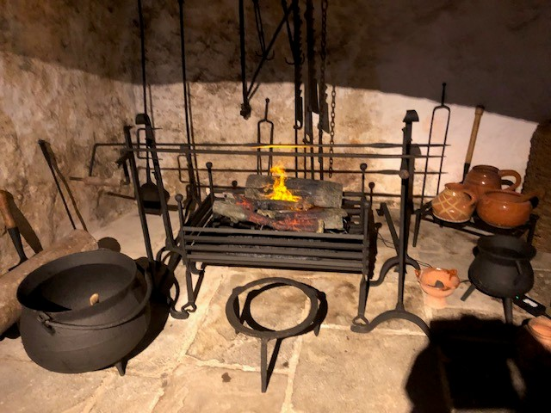
Newly painted iron work by volunteer John

Our first event is the National Lottery open week from the 15th March. This a national event which enables anyone who purchases a lottery ticket to gain free access during the week. We will also continue to allow free entry at various times throughout the year to visitors who sign up online or by collecting a newspaper token from Reach Plc, by participating in these events we can welcome even more people to National Trust properties.
The Festival of Archaeology will take place from the 19th July – 3rd August and we will have finds on display from TMH and activities for children and visiting archaeologists!
We will also offer free entry as part of “Open Doors” on the last Saturday of September. We are also taking quite a few bookings from local schools and European schools for the first time since Covid which is very encouraging.
We have welcomed one new volunteer and one returning both in our House Experience roles, we do have vacancies for House Experience and new for this year, Collections Care & Visitor Welcome Volunteers. (All on NT website). None have to be a regular commitment; we can be very flexible!
If you have missed our feature in Cartrefi Cymru on S4C it is still on BBC iPlayer. We are the second property in the first episode.

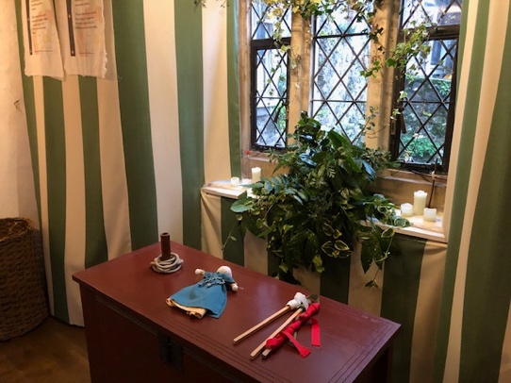
Newly repaired windows

Colby Woodland Garden
Report from Kate Mellor, Welcome Manager Colby Woodland Garden and North Pembrokeshire and Steve Whitehead, Head Gardener.

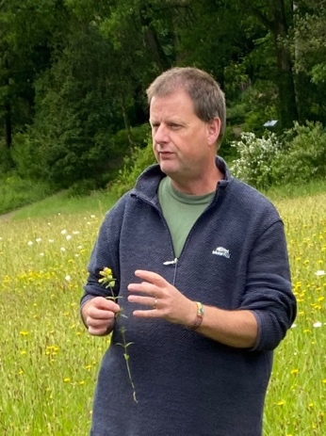
Steve Whitehead

The Garden Team at Colby were busy in the early part of the year sorting out the damage from storm Darragh, but it's likely to be late Summer before we are able to clear away the majority of the fallen trees. Large conifers were the main victims, but one enormous old beech tree was snapped clean off and some smaller oaks were crushed by the large falling conifers.

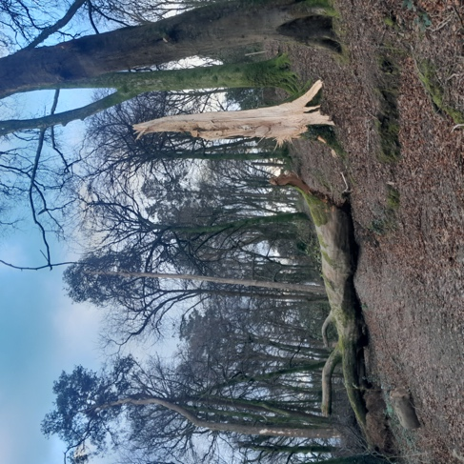
Photograph Steve Whitehead

Paths were also washed away and it will be mid-March before some areas of the garden are safe to open again, with broken branches hung up everywhere. The work isn't helped by ground conditions being so wet. Machines can't yet be used in many places in the Garden yet due to water-logged ground. We've also been working hard improving surface drainage arrangements in some areas, to try and prevent paths washing out in future, as extreme weather events are definitely increasing in both frequency and intensity.

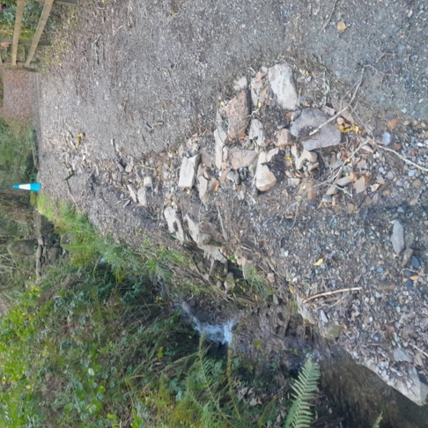
Photograph Steve Whitehead

2025 already had a busy work program of other work, much of it designed to improve biodiversity. In the meadow the mowing will be carefully planned to enable the wildflowers to continue to improve.
Southern March Orchids have now spread from their small patch at the south end of the meadow and can now be found all the way to the north end.
In the Eastwood we've been clearing holly to allow in more light for our small population of the endangered Sorbus torminalis. It was a nice surprise to find during the early stages of this work that there are far more young saplings of this species than originally thought. About thirty young trees are "clinging on" in the top of the Eastwood. If we manage to get conditions right for them to bear fruit again, there are several organisations keen to acquire seed, including the millennium seed bank at Kew, though of course we would like to plant a few more of our own! Work will also begin this year to thin out the willows around the lower ponds and let more light in, so that the pond plants and everything that depends on them can thrive. A proportion of the ponds will have to be de-silted again this year, we try to do this in rotation so that there are always some undisturbed ponds for wildlife to thrive in. Other work planned includes thinning and hard-pruning some of the densely planted parts of the garden, replacing some over-mature shrubs in and around the walled garden, and replacing the trees lost to storm Darragh with a diverse and hopefully robust selection of new saplings.

The raised beds in the walled garden were restored over the Winter and repairs to the walled garden wall should take place in March. Work will finally begin on removing the bees from the gazebo in March too. Taking them out at this time of year means they can be successfully moved to a new home while dormant. Work to repair the Gazebo roof also begins in earnest this year. Fundraising to help the restoration of the interior paintings will be a major part of our work this year. This fundraising effort will include the ‘Inside and Out Trail’ which will be a self-led trail through the garden, allowing visitors to discover pieces of the trompe l’oeil painting from the Gazebo in the Walled Garden (£3 suggested donation per trail, running every day from May 1st to November 2nd).

It is looking to be a very busy year for the Visitor Welcome team as well. With our staple events running throughout the year, such as Park Run, Artists Workshops, Pembrokeshire Woodturners Showcases’, monthly History walks and our popular Easter trail, to new events like Foraging walks, Botanical ink workshops, a Community Story Day, a Story Walk with artist Phil Okwedy and a new bi-weekly Forest School run by Plant Y Goedwig. We are working with so many new partners within our local community which is very exciting. We will also be launching our ‘Young Explorer’ Backpacks in the Easter holidays which will be free to take out. There will be backpacks for two different age groups (3-6 years and 7-12 years) that contain tree-themed activities for the whole family to get involved in. These backpacks and contents were funded by PNTA a few years ago but it has taken us a while to get them off the ground. Apologies for the wait but we are looking forward to seeing them finally in use! The Bothy Tearoom is open and the Pembrokeshire Craft Makers in the Gallery will be open at the end of March.

The Welcome Centre/Second-hand Bookshop and Walled Garden will be open weekends in March and every day from March 31st. We are working towards getting the three coloured waymarked trails on the Colby Estate onto the website to encourage more visitors to visit the wider Estate. We are also working with the Vincent Wildlife Trust on their 3-year Barbastelle Bat Conservation Project to increase the distribution of barbastelles throughout Pembrokeshire and ultimately Wales.
We will have some workshops later on in the year at Colby and will have some interpretation going up onsite around this work. Cathy Jewson who is leading on the project will also be running a Bat Walk at Colby in August for our visitors and a Make a pine cone bat’ craft event in October half term.
If any PNTA members would like to help out with car parking or handing out Easter eggs on our Easter trail (18th to 21stApril) please get in touch with kate.mellor@nationaltrust.org.uk.
We have some volunteers already, thank you so much for all you do!

It's going to be a busy year; lots of positive things to look forward to in 2025!

PNTA WEBSITE
The Association has a website at www.pembsnta.org.uk It contains information about the Association, our Events Programme, the Newsletter and
Association news items. We hope it will be useful to existing members and attract new members. Together with email and MailChimp, it helps us provide up to date information for members.

MEMBERSHIP SUBSCRIPTIONS
If you intend to renew your membership and haven't yet done so, would you kindly send a cheque for £5 (single) or £8 (double) to the Membership Secretary - Mrs Sheila Ashton, Pondmeadow, Wiston, Haverfordwest SA62 4PR. (01437 731525), or better still, complete a standing order form which is available on the PNTA website. Subscriptions run from January to January. Your effort will be much appreciated.

CONTACT BY EMAIL
We are continuing to increase our use of electronic communications. If you have an email address and are not receiving messages, such as MailChimp from us, or have just started an email account, please email our Membership Secretary, Sheila Ashton at robashton95@yahoo.co.uk

MAILCHIMP
I aim to send these email updates at approximately monthly intervals. These are mainly reminders of forthcoming events, but include other bits of news that I hope will be of interest.
If you have been missing out, but would like to subscribe, please email me at andrew.pnta@gmail.com
If you have already provided an email address but are not seeing Mailchimp, please check your junk/spam file.

NEWSLETTER BY E MAIL.
This edition of the newsletter is being sent out by e mail unless you have specifically asked for a paper copy.
This will enable the society not only to save money on paper and postage (and of course do our bit to save trees) but also allow us to contact you at short notice when we are able to arrange events.
Some of you will already be receiving Andrew's messages via mailchimp and of course the newsletter is always published on the website, but an e mail with the newsletter attached would be straight to your inbox.

We are of course, aware that not all members have access to a computer or an email account and therefore the newsletter will be sent out to you through the postal service unless you opt for the digital service.

OFFICERS AND COMMITTEE
Your officers and committee members
are as follows (* Officer):

CHAIRMAN* Jane Mason

VICE-CHAIRMAN* Sheila Ashton

TREASURER* Stephen Flather

SECRETARY* Annie Weaver
Tel: 01646 831323

MEMBERSHIP SECRETARY
Sheila Ashton
Tel: 01437 731525

MAILCHIMP Andrew Weaver

DID YOU KNOW?

Most front door frames had a wooden bar fitted at the bottom to hold the loose thresh or straw on the floor and prevent it escaping into the street when the door was opened. This is the origin of the saying CARRYING THE BRIDE OVER THE THRESHOLD.
Most people had infrequent baths and people would carry a posy of flowers to mask any smells. This is where the tradition of a bride carrying a bouquet originates.
Contributed by the TMH team.

NEWSLETTER Marilyn James

P.R. Jane Mason

DAY TRIPS Graham Brace

WALKS Steve Drinkwater
Tel. 01834 869970

WINTER SPEAKER. Graham & Sandra
ADMINISTRATION. Wright

ADDITIONAL SOCIALS. Lyn Humphries

